**Why Do We Fall Ill?**

# Health and Disease

* **Health** is defined as the state of complete physical, mental and social well-being.
* The health of an individual is affected by changing internal and external factors including personal, economic, environmental and social factors.
* **Disease** is the departure from normal health through a structural or functional disorder of the body.

## Causes of Diseases

|  |  |
| --- | --- |
| Intrinsic/Internal Factors | * These are disease-causing factors which exist within the human body. * Genetic disorders. Example: Haemophilia |
| Extrinsic/External Factors | * These are disease-causing factors which enter the human body from outside and cause a disease. * Disease-causing microorganisms. Example: Malaria |
| Levels of Immediate Causes | * First-level cause: Primary cause/causative agent: Bacteria, virus * Second-level cause: Secondary cause: Lack of good nourishment * Third-level cause: Tertiary cause: Poverty |

**Types of Diseases**

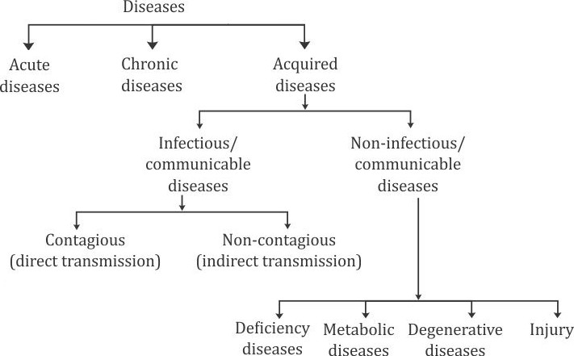

* Diseases in which the symptoms are quickly visible in the body and last for a shorter duration are called **acute** diseases. Examples: Common cold, malaria
* Diseases which are long-term, with their symptoms lasting for months or years, are called **chronic**

diseases. Examples: Elephantiasis, tuberculosis

* Diseases which develop after birth are called **acquired** diseases.
* Diseases caused by infectious agents or pathogens are called communicable or infectious diseases. Examples: Tuberculosis, chickenpox, measles
* Diseases which do not spread from one person to another are called non-communicable or **non- infectious** diseases. Examples: Beriberi, scurvy, arthritis

## Differences between Infectious and Non-infectious Diseases

|  |  |
| --- | --- |
| **INFECTIOUS DISEASES** | **NON-INFECTIOUS DISEASES** |
| 1. Caused by attack of pathogens | 1. Caused by factors other than pathogens |
| 2. Caused by extrinsic factors | 2. Caused by intrinsic factors |
| 3. Transmitted from one person to  another | 3. Do not get transmitted from one person  to another |
| 4. Transmission of diseases occurs  through direct contact or some medium | 4. Transmission in hereditary diseases is  from parent to offspring |
| 5. Examples: Cholera, malaria | 5. Examples: Diabetes, goitre |

**Infectious Diseases**

**Infectious Agents**

**Viruses Bacteria Fungi Protozoa Metazoa**

**Mites**

* Scabies
* Elephantiasis, ascariasis
* Malaria, amoebic dysentery, Kala-azar
* Skin infections, dandruff, ringworm
* Typhoid, cholera, tuberculosis, tetanus
* AIDS, chickenpox, influenza, poliomyelitis

**Means of Spread of Infectious Diseases**

|  |  |
| --- | --- |
| Air-borne diseases | Spread through air when droplets of pathogens are expelled into the air because of coughing, sneezing or talking.  Examples: Influenza, meningitis |
| Water-borne diseases | Caused by consumption of contaminated water.  Examples: Typhoid fever, cholera, hepatitis A |
| Food-borne diseases | Caused by consumption of food contaminated with chemical toxins or pathogens.  Examples: Taeniasis, trichinosis |
| Vector-borne diseases | Caused by pathogens transmitted by vectors such as insects and ticks.  Examples: Malaria, elephantiasis |
| Sexually transmitted  diseases | Caused by pathogens transmitted by sexual contact.  Examples: AIDS, syphilis |
| Fomite-borne diseases | Caused by pathogens present on inanimate objects such as clothing and bedding used by infected people.  Examples: Scabies, ringworm |

**Organ-specific and Tissue-specific Manifestations of Diseases**

* The **signs** and **symptoms** of a disease depend on the tissue or organ which the microbe targets.
* The severity of **disease manifestation** depends on the number of microbes within the body.
* During infection, the immune system gets activated. It sends many soldier cells to the affected tissue to kill the microbes. This causes inflammation.
* **Inflammation** is due to the escape of some chemicals which cause allergic reactions in our body. They attract blood supply because of which the amount of blood and the temperature of the surrounding area increase. The consequent swelling of the area is called **oedema**.
* **Plasma** and **white blood cells** (WBCs) of the immune system of the body are discharged at the affected site. Plasma contains products such as **antibodies** and **macrophages** which kill or inhibit the growth of pathogens.
* Doctors carry out **confirmatory tests** such as laboratory tests of blood, urine and stool or even perform an X-ray to confirm the presence of a disease.

# Principles of Treatment of Diseases

**Treatment of a Disease**



**Reducing the Effect**

* Medicines

reduce

the

symptoms associated with the disease.

* Taking rest helps to conserve

our energy.

**Killing the Cause**

* Pathogenic microbes can be killed by using medicines or antibiotics without affecting the metabolism of the host.
* Antibiotics can be used to cure bacterial infections as these chemical compounds block the important biochemical pathways of bacteria.

**Principles of Prevention of Diseases**

* **Prevention of diseases follows three basic principles:**



Maintenance of personal and public hygiene

Availability of proper and sufficient food and water for everyone

Immunisation

## General Ways of Prevention of Infectious Diseases

* We can prevent exposure to **air-borne microbes** by providing living conditions which are not overcrowded.
* We can prevent exposure to **water-borne microbes** by providing safe, filtered and boiled drinking water.
* We can provide clean environments to prevent exposure to **vector-borne microbes**. This would not allow their multiplication.

## Specific Ways of Prevention of Infectious Diseases

* **Immunisation** is the process by which an individual's immune system is equipped to fight off infectious agents.
* **Vaccination** provides active immunity.
* Vaccines against some common diseases such as BCG vaccine, DPT vaccine, polio vaccine, vaccines for tetanus, diphtheria, whooping cough, measles and many others have been administered in India.